LANDIS-II Base Hurricane v3
Extension User Guide

Robert M. Scheller, North Carolina State University
Paul Schrum, North Carolina State University
James Lamping, University of Oregon

Last Revised: July 3, 2024

Table of Contents
1 Introduction 3
1.1 Hurricane Disturbances 3
1.2 Locating the Coast Line 4
1.3 Landfall 5
1.4 Modelling of Landfall Wind Speed 7
1.5 Major Releases 8
1.5.1 Version 3.0 (August 2024) 8
1.5.2 Version 2.0 (August 2023) 8
1.6 Minor Releases 8
1.7 Acknowledgements 8
2 Input File 9
2.1 LandisData 9
2.2 Timestep 9
2.3 HurricaneRandomNumberSeed (integer, optional) 9
2.4 StormOccurrenceProbabilities (table) 9
2.5 Landfall Wind Speed 10
2.5.1 LowBoundLandfallWindSpeed (integer) 10
2.5.2 ModeLandfallWindSpeed (integer) 10
2.5.3 HighBoundLandfallWindSpeed (integer) 10
2.6 CoastalSlope (integer) 10
2.7 MeanLandfallIntersectionX (integer) 10
2.8 MeanLandfallIntersectionY (integer) 11
2.9 LandfallSigma (integer) 11
2.10 StormDirectionMu (integer) 11
2.11 StormDirectionSigma (integer) 11
2.12 MinimumWindSpeedforDamage (double) 11
2.13 ExposureMaps (table) 11
2.14 WindSpeedVulnerabilities (table) 12
2.15 MapNames 12
2.16 LogFile 13
2.17 WindReducationTableCSV (Optional) 13
3 Output Files 14
3.1 Max Wind Speeds Maps 14
3.2 Hurricane Events Log 14
3.2.1 Time 14
3.2.2 Year 14
3.2.3 HNumber 14
3.2.4 LandfallLatitude 14
3.2.5 LandfallMaxWindSpeed 14
3.2.6 PathHeading 14
3.2.7 StudyAreaMaxWindspeed 15
3.2.8 StudyAreaMinWindspeed 15
3.2.9 ImpactsStudyArea 15

Introduction
This document describes the Biomass Hurricane extension for the LANDIS-II model. For information about the model and its core concepts, see the LANDIS-II Conceptual Model Description.
Base Hurricane models landscape-scale wind events (e.g., tropical cyclones) of varying strength making landfall along a coast. The model is concerned only with sustained wind. Rainfall, storm surge, tornadoes, or inland flooding are not modelled.
Mortalities are computed based on the maximum wind speed of the entire event. Though wind speeds vary over the duration of the event, only the maximum wind speed is considered for mortality computation. Other factors such as the effect of soil saturation may be considered to be included in the statistical representation of the Wind Speed Vulnerabilities table.
The terms "hurricane", "tropical cyclone", and "storm" are used interchangeably in this documentation.

Hurricane Disturbances
During a hurricane time step, multiple tropical cyclone events may occur on the landscape (Figure 1). A storm which is generated by the model may hit the study area, but it may miss it. If a storm passes far enough away from the study area such that the maximum wind speed is too low, no damage is computed.
For any year, the number of wind events is randomly generated.
For each storm, initiation parameters are created: Landfall Latitude, Maximum Wind Speed at Landfall, and Storm Track Heading.
Based on these initiation parameters, a Maximum Wind Speed Field is generated on a continental grid, which is then used to compute maximum wind speed for each site of the study area.
Cohort mortality probabilities are computed based on cohort species and age compared to the maximum wind speed based on the Wind Speed Vulnerabilities table.
Figure 1. A flow chart of the order of processes.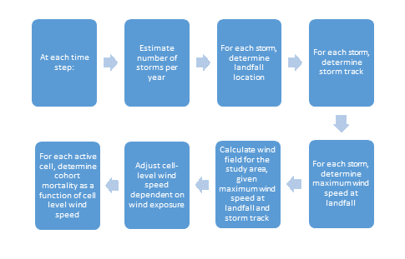
Base Hurricane does not provide a way to allow storm occurrence probabilities to change over time or to allow maximum wind speed over time.

Locating the Coast Line
To simulate large storms with a direction and width, it is necessary to spatially identify a ‘coastline’ that storms intersect before proceeding towards and into the study area. The coastline need not literally represent a coastline; it can be any plane through which storms travel before striking the study area (Figure 2).
The mean storm landfall location is identified with an X and Y coordinate located within the study area. A coastal ‘slope’ determines the arrangement of the coast relative to the storm center point.
Note that the overall study area must be large enough to accommodate a coastline that is large enough to produce all storms that could strike the study area. If the study area is small relative to the size of expected storms, it may be necessary to create a landscape with a small fraction of active cells. There is, however, no penalty within LANDIS-II for having one or many inactive cells. They consume neither memory or require any additional processing.
A storm can originate anywhere along the coastline (see below) and will progress in a direction determined from a normal distribution.
Figure 2. Diagram of the coastline relative to the study area, active cells, and mean landfall location and an example of a potential storm track.
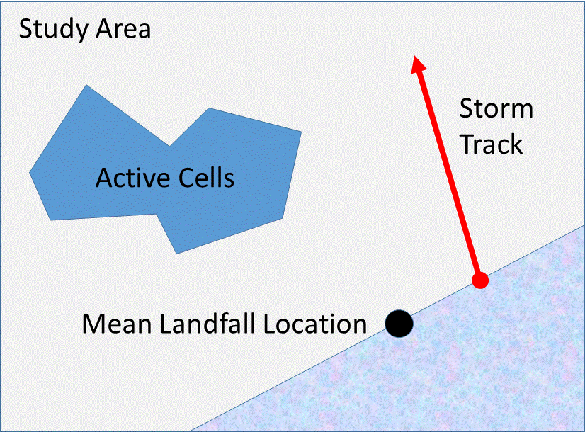

Landfall
The location of each storm along the coastline is selected from a normal distribution assuming a mean (mu) of 0.0 (located at the Mean Landfall Intersection) and a variance (sigma).
If the bearing of the coast (the ‘coastal slope’) determines how storm locations are distributed. For example, a strictly east-west bearing will have a slope of 0. A bearing from southwest to northeast (e.g., the Atlantic coast of U.S.) has a bearing of roughly 1.0.
If the coastal slope is between 1.0 and -1.0 (a primarily east-west orientation), the randomly selected normal value (with mu = 0.0) will be applied to the east-west orientation (‘x-axis’).
If the coastal slope is greater than 1.0 or less than -1.0 (a coast that is primarily vertical, with a north-south bearing), the randomly selected normal value (with mu = 0.0) will be applied to the y-axis.
As an example, if the randomly selected normal value is -5.0, the randomly generated normal values will be applied to the north-south (‘y-axis’) because the coast has a bearing that is primarily north-south.
Note that the landfall of a storm can be outside of the study area, allowing the storm track to originate outside the study but to pass into it (Figure 3).
Figure 3. The distribution of storms along the coastline is determined by the Mean Landfall Location and a normal distribution with mu = 0.0 (centered on the mean landfall location) and a sigma (variance) determined by the user.
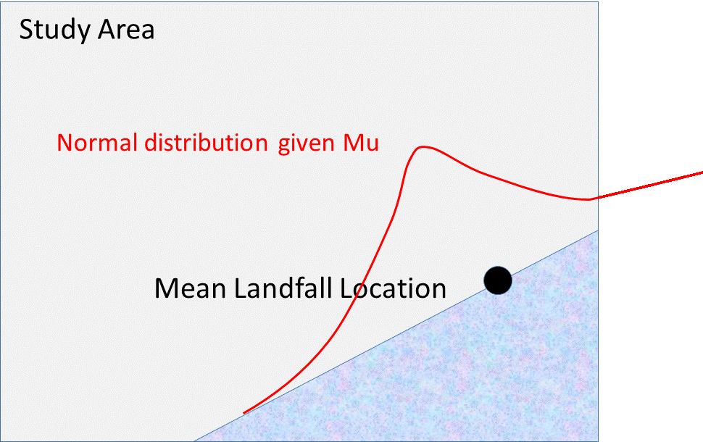

Modelling of Landfall Wind Speed
An important controlling parameter for the model is the maximum wind speed of the storm when it makes landfall. After landfall the wind speeds are assumed to decrease.
Each storm is assigned a random landfall wind speed on a log-normal distribution. The scale of these values is determined by three parameters set in the input file: LowBoundLandfallWindSpeed, ModeLandfallWindSpeed, and HighBoundLandfallWindSpeed (Figure 4).
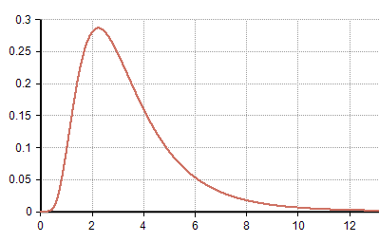
High Bound
Landfall Wind Speed
Mode Landfall Wind Speed
Low Bound
Landfall Wind Speed
Probability
Wind Speed
Figure 4. Log-normal distribution of randomly generated landfall wind speed values. Modified from http://wiki.analytica.com/index.php?title=File%3ALogNormal(median%3D3,stddev%3D2).png

Major Releases

Version 3.0 (August 2024)
Updated to compatible with Core v8. Renamed Biomass Hurricane to reflect new structure.

Version 2.0 (August 2023)
The first official release of Base Hurricane.

Minor Releases

Acknowledgements
Funding for the development of this LANDIS-II extension has been provided by the United States Department of Defense and the National Science Foundation.

Input File
The input parameters for this extension are specified in one input file. This text file must comply with the general format requirements described in section 3.1 Text Input Files in the LANDIS-II Model User Guide.

LandisData
This value of this parameter must be " Hurricane".

Timestep
This parameter is the timestep of the hurricane extension. Value: integer > 0. Units: years.

HurricaneRandomNumberSeed (integer, optional)
New to LANDIS-II: The user can determine a random number seed that is separate from the Core random number seed. Doing so allows other stochastic events to vary separately from hurricanes. For example, the user might want all fires to remain the same while hurricanes varied or vice versa.

StormOccurrenceProbabilities (table)
The number of storms which make landfall in a given year is determined with the Storm Occurrence Probabilities table. The number of storms is randomly generated at each time step. The probabilities should add up to 1.0.
Column 1: Storms per year (integer)
Column 2: The probability of that number of storm.
An example:

>> Likelihood a given year will have a given number of storms.
StormOccurrenceProbabilities
>> Storms
>> Per
>> Year Probability << Sum must = 1.0
0 0.60
1 0.33
2 0.06
3 0.01

Landfall Wind Speed
Landfall Wind Speed is randomly determined with parameters controlled by three input file variables.

LowBoundLandfallWindSpeed (integer)
This is the lowest wind speed that a wind storm may have.

ModeLandfallWindSpeed (integer)
This is the most frequent wind speed that a wind storm may have.

HighBoundLandfallWindSpeed (integer)
This is the highest wind speed that a wind storm may have.

CoastalSlope (integer)
The coastal ‘slope’ determines the arrangement of the coastline; the coastline runs through the mean landfall point.

MeanLandfallIntersectionX (integer)
The Mean Landfall Intersection is the average landfall location (point) for storms along the coast.
It is measured as the distance of the mean storm intersection from the western edge of the study area, in kilometers.

MeanLandfallIntersectionY (integer)
The distance of the mean storm intersection from the southern edge of the study area, in kilometers.

LandfallSigma (integer)
The location of each storm along the coastline is selected from a normal distribution assuming a mean (mu) of 0.0 (located at the Mean Landfall Intersection) and a variance (sigma).

StormDirectionMu (integer)
The mean storm direction in degrees. A normal distribution is used to determine the actual direction, in combination with the sigma value, below.

StormDirectionSigma (integer)
The variance of the storm direction.

MinimumWindSpeedforDamage (double)
Below this wind speed, cohort mortality is not calculated.

ExposureMaps (table)
New for version 2: The land surface can vary by exposure, dependent on wind direction. For example, a storm out of due south may affect north facing slopes to a lesser degree. Therefore a table is now required indicating a map and an associated degree. For each storm generated, the closest degree map (calculated as the minimum angle between two directions) is used to modify wind speeds.
The map itself should contain nine (9) classes, each associated with a proportion reduction in wind speed (0.1 – 0.9), whereby class 1 = 0.1, class 2 = 0.2, …, class 9 = 0.9.
The table has two columns (there is no header):
Column 1: Degree (integer)
Column 2: Map Name (file name)
The

WindSpeedVulnerabilities (table)
High winds kill cohorts at different rates according to species and age. To represent this, the Wind Speed Vulnerabilities table represents mortality probabilities.
Note that there must be at least one line per species and at least one wind-speed:mortality pair. If your data are limited, you do not have to have more than this minimum.
Column 1: The name of the species. This must be consistent with species names in the species txt file.
Column 2: The maximum cohort age in years for the given table row. The final row for any species should have a very high age (such as 999) to represent the oldest cohorts.
Column 3: Contains the colon-delimited pairs of values where the first number is the wind speed and second number is the probability of mortality. For example, a value of "60:0.05" means that site wind speeds of less than 60 kph (or mph if set to English) result in 5% cohort mortality.
Example table:
WindSpeedVulnerabilities
>> Species MaxAge Mortality Probabilities
DougFir 999 75:50
LobPine 30 60:0.05 75:0.18 110:0.75 140:1.0
LobPine 60 60:0.1 75:0.23 110:0.75 140:1.0
LobPine 999 60:0.1 75:0.29 110:0.75 140:1.0

MapNames
This file parameter is the template for the names of the wind severity output maps. The parameter value must include the variable “timestep” to ensure that the maps have unique names (see section 3.1.8.1 Variables in the LANDIS-II Model User Guide). The user must indicate the file extension. The user must also include sub-directory name(s) as needed.

LogFile
The file parameter is the name of the extension’s event log file.

WindReducationTableCSV (Optional)
In many places, stand structure will co-determine vulnerability to wind mortality. An old stand with a complex structure may be the least vulnerable. An even-aged stand may be the most vulnerable. The purpose of this table is to allow simple stand complexity data to inform wind speed (by reducing effective wind speed) and, hence, to reduce vulnerability.
The input is the name of a CSV file that provides a link to the Output Cohort Statistics extension, specifically the Evenness calculation. Please see that User Guide for the definition of evenness.
The table must have two columns: RangeMaximum and FractionWindReduction. RangeMaximum is the maximum of a bin of Evenness values. The lowest RangeMaximum will have a minimum of zero. These bins are assigned an associated FractionWindReduction (0.0 – 1.0).
Note: You cannot increase wind speed using this table.

Output Files
The wind extension generates two types of output files: a) a map of maximum wind speed for each impacting storm, and b) a log of hurricane events for the entire scenario.

Max Wind Speeds Maps
The max wind speeds map shows the maximum wind speed for each cell of the study area for a given storm, but only if that storm has impact on the study area.

Hurricane Events Log
The event log is a comma-separated-value text file that contains information about every storm over the course of the scenario. Every storm is logged whether it impacts the study area or not.

Time
The time step of the given storm.

Year
The year number of the given storm.

HNumber
The hurricane number of the given storm in the current year.

LandfallLatitude
The latitude where the given storm makes landfall (crosses the coast line).

LandfallMaxWindSpeed
The wind speed of the given storm at the point of landfall.

PathHeading
The direction (in Azimuth form) that the given storm takes as it progresses inland.

StudyAreaMaxWindspeed
The highest maximum wind speed of any active site in the study area.

StudyAreaMinWindspeed
The lowest maximum wind speed of any active site in the study area.

ImpactsStudyArea
"Yes" if the given storm has a chance of causing any mortalities in the study area. "No" if it does not.

